**Date: 10-11-2020**

**Experiment 6**

**Implementation Of Linked List**

**Done By :** Rohit Karunakaran **Roll no:** 58

**Aim:** Implementation of linked list

**Data Structure Used:** Linked List

**Operation Used:** Comparisons

**Algorithm:**

**Algorithm for InsertFront**

**Input:** Header Node of a linked list (LL) and the ITEM to be inserted

**Output:** Linked List with the new node inserted after the Header node

**Data Structure:** Linked List

Step 1 : Start

Step 2: new = GetNode(Node)

Step 3: if(new==NULL) then

Step 1: Print(“No Memory space available”)

Step 2: Stop

Step 4: else

Step 1: new→data = ITEM

Step 2: new→link = Header→link

Step 3: Header→link = new

Step 5: endif

Step 6: Stop

**Description of the Algorithm:** This Algorithm inserts a node just after the header node

**Algorithm for InsertBack**

**Input:** Header Node of a linked list (LL) and the ITEM to be inserted

**Output:** Linked List with the new node inserted at the end of the List

**Data Structure:** Linked List

Step 1 : Start

Step 2: new = GetNode(Node)

Step 3: if(new==NULL) then

Step 1: Print(“No Memory space available”)

Step 2: Stop

Step 4: else

Step 1;ptr = Header

Step 2: while(ptr→ link !=NULL) do

Step 1: ptr=ptr→link

Step 3: endWhile

Step 4:new→data = ITEM

Step 5: new→link = NULL

Step 6: ptr→link = new

Step 5: endif

Step 6: Stop

**Description of the Algorithm:** This algorithm goes to the end of the List and inserts a node after the last node

**Algorithm for InsertFront**

**Input:** Header Node of a linked list (LL), the ITEM to be inserted and the position (POS)

**Output:** Linked List with the new node inserted at the corresponding position

**Data Structure:** Linked List

Step 1 : Start

Step 2: new = GetNode(Node)

Step 3: if(new==NULL) then

Step 1: Print(“No Memory space available”)

Step 2: Stop

Step 4: else

Step 1: i=-1

Step 2: ptr = Header

Step 3: while(i<pos-1 and ptr!=NULL) then

Step 1: i++

Step 2: ptr=ptr→link

Step 4: endwhile

Step 5: if(ptr!=NULL) then

Step 1: new→data = ITEM

Step 2: new→link = ptr→link

Step 3: ptr→link = new

Step 6: else

Step 1: print(“Given position is not found”)

Step 2: Stop

Step 7: endif

Step 5: endif

Step 6: Stop

**Description of the Algorithm:** This algorithm traversed the List, on reaching the node at the index position passed it inserts a new node at that position. Eg: if the List is “34 21 56 12” and assume the elements are indexed from 0 (even though it is a linked list and indexing of elements don’t make any sense) if I want to insert 23 at position 2. The resulting Linked list will be

“34 21 23 56 12”.

**Algorithm for DeleteFront**

**Input:** Header Node of a linked list (LL)

**Output:** The item removed from the list

**Data Structure:** Linked List

Step 1 : Start

Step 2: if(Header→link ==NULL) then

Step 1: print(“Linked List is empty”)

Step 2: Stop

Step 3: else

Step 1: ptr = Header→link

Step 2: Header→link = ptr→ link

Step 3: ITEM = ptr→data

Step 4: ReturnNode(ptr)

Step 5: return ITEM

Step 4: endif

Step 5: Stop

**Description of the Algorithm:** This algorithm deletes the node just after the header node

**Algorithm for DeleteRear**

**Input:** Header Node of a linked list (LL)

**Output:** The item removed from the end of the list

**Data Structure:** Linked List

Step 1 : Start

Step 2: if(Header→link ==NULL) then

Step 1: print(“Linked List is empty”)

Step 2: Stop

Step 3: else

Step 1: ptr = Header →link

Step 2: ptr1 = Header

Step 3: while(ptr→link!=NULL) do

Step 1: ptr1=ptr

Step 2: ptr = ptr→link

Step 4: EndWhile

Step 5: ITEM = ptr→data

Step 6: ptr1→link = ptr→link

Step 7: ReturnNode(ptr)

Step 8: return ITEM

Step 4: EndIf

Step 5 : Stop

**Description of the Algorithm:** This algorithm deletes the Node at the end of the linked list

**Algorithm for Delete from a position**

**Input:** Header Node of a linked list (LL) and the position of the node to be removed

**Output:** The item removed from the specified position of the list

**Data Structure:** Linked List

Step 1 : Start

Step 2: if(Header→link == NULL)

Step 1: Print(“The List Is Empty”)

Step 2: Stop

Step 3: else

Step 1: i=-1

Step 2: ptr = Header

Step 3: while(i<pos-1 and ptr!=NULL) then

Step 1: i++

Step 2: ptr=ptr→link

Step 4: endwhile

Step 5:if(ptr→link ==NULL)

Step 1: ITEM = ptr->link→ data

Step 2: ptr1 = ptr→link

Step 3: ptr→link = ptr1→link

Step 4: ReturnNode(ptr1)

Step 5:return(ITEM)

Step 6: else

Step 1: Print(“Index Out Of Bounds”)

Step 2: Stop

Step 7:endif

Step 4: endif

Step 5: Stop

**Description of the Algorithm:** Just like the insertion at any position algorithm passing the position of the element to be deleted will remove the element. It takes a pointer (ptr) to the element right before the one to be deleted and then links the link part of ptr to the link of the element to be deleted.

**Program Code:**

/********************************

* Linked List Implementation

* Done By: Rohit Karunakaran

* ******************************/

#include<stdio.h>

#include<stdlib.h>

typedef struct Linked_List_Node

{

struct Linked_List_Node *link;

int data;

}Node;

void initList(Node* Header)

{

//Header = (Node*) malloc (sizeof(Node));

Header->link = NULL;

Header->data = 0;

}

//Insertion Algorithms

void insertStart(Node *Header,int val)

{

Node *new_node = (Node*) malloc(sizeof(Node));

if(new_node!=NULL)

{

new_node->data = val;

new_node->link = NULL;

Node* ptr = Header->link;

Header->link = new_node;

new_node->link=ptr;

}

else

{

printf("Insertion Not Possible\n");

exit(1);

}

return ;

}

void insertAt(Node *Header,int val,int pos) //Insert at a specified position from the header node

{

Node *new_node = (Node*) malloc(sizeof(Node));

if(new_node!=NULL)

{

Node* ptr = Header;

int index = -1;

while(index<pos-1 && ptr!=NULL)

{

ptr=ptr->link;

index ++;

}

if(ptr !=NULL)

{

new_node->link = ptr->link;

new_node->data = val;

ptr->link =new_node;

}

else

{

printf("Given position is not found \nExiting......\n");

exit(1);

}

}

else

{

printf("Insertion Not Possible");

exit(1);

}

return ;

}

void insertEnd(Node *Header,int val)

{

Node *new_node = (Node*) malloc(sizeof(Node));

if(new_node!=NULL)

{

new_node->data = val;

new_node->link = NULL;

Node* ptr=Header;

while(ptr->link != NULL)

{

ptr = ptr->link;

}

ptr->link = new_node;

}

else

{

printf("Insertion not possible");

exit(1);

}

return;

}

//Deletion Algorithms

int deletionBegin(Node *Header)

{

if(Header->link == NULL)

{

printf("Deletion not possible. The list is empty");

exit(0);

return 0;

}

else

{

Node* ptr = Header->link;

Header->link = ptr->link;

int elem = ptr->data;

free(ptr);

return elem;

}

}

int deletionAt(Node* Header, int pos)

{

if(Header->link == NULL)

{

printf("Deletion not possible. The list is empty");

exit(0);

return 0;

}

else

{

int index = -1;

Node* ptr = Header;

while(index<pos-1&&ptr!=NULL)

{

ptr=ptr->link;

index++;

}

if(ptr->link!=NULL)

{

int elem = ptr->link->data;

Node* red = ptr->link;

ptr->link = ptr->link->link;

free(red);

return elem;

}

else

{

printf("Index Is out of Bounds \n");

exit(1);

return 0;

}

}

}

int deletionEnd(Node* Header)

{

if(Header->link == NULL)

{

printf("Deletion not possible. The list is empty");

exit(0);

return 0;

}

else

{

Node* ptr=Header->link;

Node* ptr1=Header;

while(ptr->link!=NULL)

{

ptr1=ptr;

ptr=ptr->link;

}

int elem = ptr->data;

ptr1->link = NULL;

free(ptr);

return elem;

}

}

void displayList(Node* Header)

{

Node* ptr = Header->link;

if(ptr!=NULL)

{

printf("The List is : ");

while(ptr!=NULL)

{

printf("%d ",ptr->data);

ptr=ptr->link;

}

printf("\n");

}

else

{

printf("The Linked list is empty\n");

}

}

int menu(Node* Header)

{

int RUN = 1;

while(RUN)

{

printf("\n");

printf("=============================\n");

printf(" MENU \n");

printf("=============================\n");

printf("1.Insert At Begining\n");

printf("2.Insert At End\n");

printf("3.Insert At Position\n");

printf("4.Delete From Begining\n");

printf("5.Delete From End\n");

printf("6.Delete From Position\n");

printf("7.Display the linked List\n");

printf("8.Exit\n");

printf("Enter Choice: ");

int choice;

int elem;

int pos;

scanf("%d%*c",&choice);

switch(choice)

{

case 1: printf("Enter the element to be inserted: ");

scanf("%d%*c",&elem);

insertStart(Header,elem);

printf("\n");

break;

case 2: printf("Enter the element to be inserted: ");

scanf("%d%*c",&elem);

insertEnd(Header,elem);

printf("\n");

break;

case 3: printf("Enter the element to be inserted: ");

scanf("%d%*c",&elem);

printf("Enter the postion to insert %d : ",elem);

scanf("%d%*c",&pos);

insertAt(Header,elem,pos);

printf("\n");

break;

case 4: elem = deletionBegin(Header);

printf("The Element removed is %d",elem);

printf("\n");

break;

case 5: elem = deletionEnd(Header);

printf("The Element removed is %d",elem);

printf("\n");

break;

case 6: printf("Enter the postion of the element to be deleted : ");

scanf("%d%*c",&pos);

elem = deletionAt(Header,pos);

printf("The Element removed is %d",elem);

printf("\n");

break;

case 7: displayList(Header);

break;

case 8: RUN=0;

break;

default: printf("Enter a valid choice\n");

printf("\n");

break;

}

}

printf("Exiting........\n");

return RUN;

}

int main()

{

Node *Header = (Node*)malloc(sizeof(Node));

initList(Header);

return menu(Header);

}

**Result:** The Program is successfully compiled and the desired result is obtained

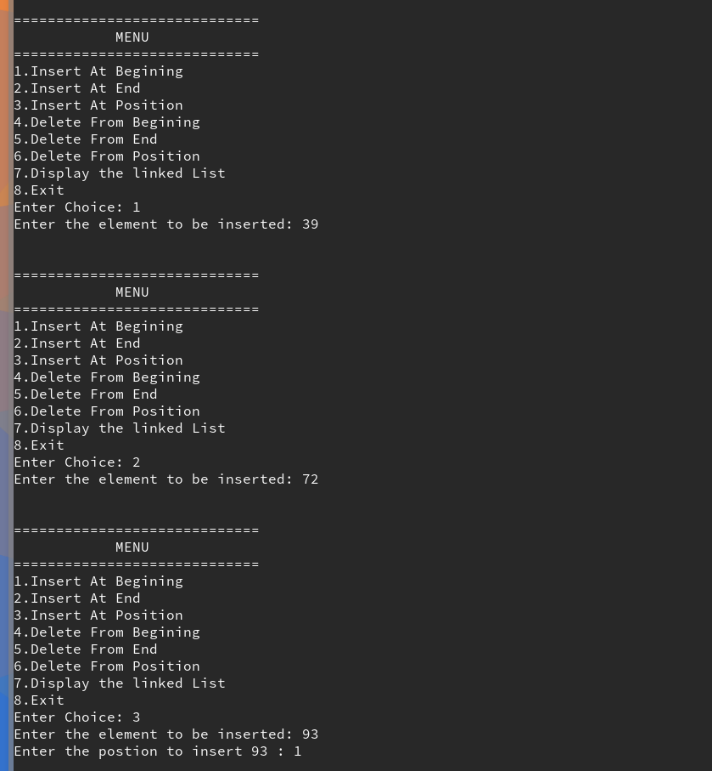**Sample Input and output**

